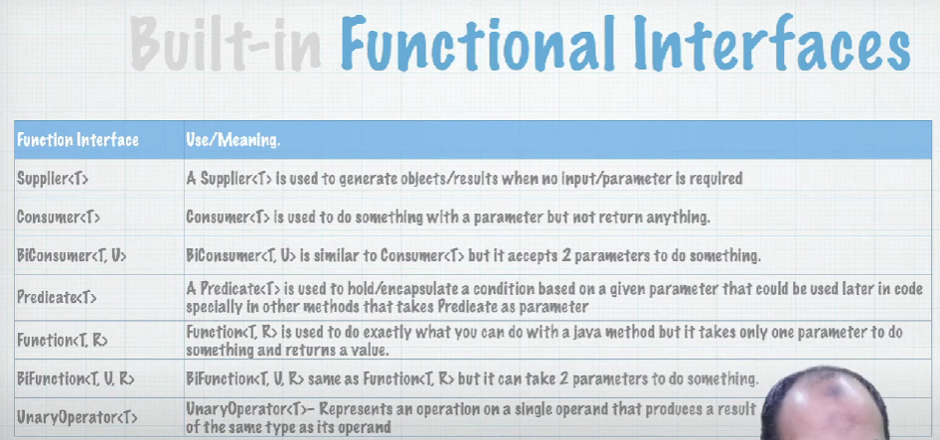F

* Supplier<T>: generate an objects of type T (no input/parameters is required)
* Consumer<T>: return void
* Predicate<T>: the most uses as conditions checker
* Function<T, R>: take T as input and R a return value

